ManageCraft Docs:

**Frame C: The 2nd frame of the application**

* Make a far left panel and a far right panel using QWidgets as place holders or separated by a QHBoxLayout or use both.
* Left panel use QFormLayout:
  + Top row should be a label with the Server IP address which I will automatically insert from Ngrok upon server *Start*, the rest will be for user inputs. Once you’ve set the left QWidget to the *Form Layout*, right click in the area of the layout then click **Add form layout row…** *(Note: An alternative to Form Layout is using a Vertical Layout then using Horizontal Layout for EACH widget you add to the Vertical Layout)*
  + Level Name **(Line Edit Input)**
  + Message Of The Day **(Line Edit Input)**
  + Level Seed **(Line Edit Input)**
  + Resource Pack **(Line Edit Input)**
  + OP Permission Level **(Horizontal Slider Input)**
  + Difficulty **(ComboBox Input)**
  + Gamemode **(ComboBox Input)**
  + Force Gamemode **(Binary Input)**
  + PVP **(Binary Input)**
  + Allow Flight **(Binary Input)**
  + Allow Nether **(Binary Input)**
  + Announce Player Achievements **(Binary Input)**
  + Spawn NPCs **(Binary Input)**
  + Spawn Animals **(Binary Input)**
  + Spawn Monsters **(Binary Input)**
  + Generate Structures **(Binary Input)**
  + Enable Command Block **(Binary Input)**
  + Hardcore Mode **(Binary Input)**
  + Max Players **(Spin Box Input)**
  + Max Build Height **(Spin Box Input)**
  + Player Idle Timeout **(Spin Box Input)**
  + Spawn Protection **(Spin Box Input)**
  + View Distance **(Spin Box Input)**
* Right panel use QListWidget:

*Example View:*

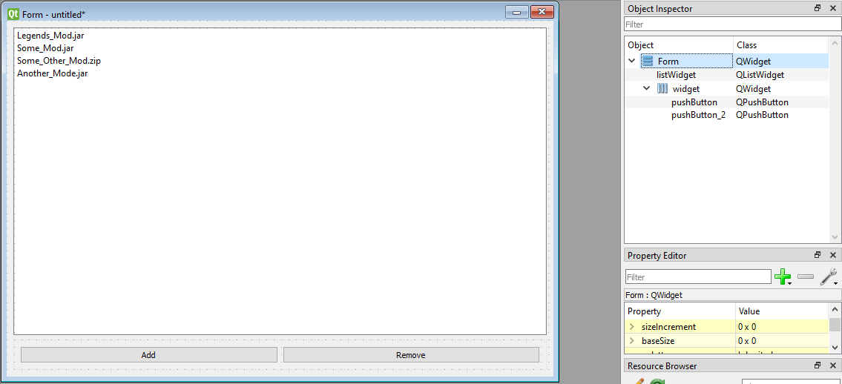

* Don’t actually add the items into the list widget. Those are just mock mod names. My idea for this is so that the user can select multiple mods and remove them. And when they click add it lets them select a mob from their local computer file system.
* I’ll add file icons later to make it prettier. I’ll also allow it to select multiple items. You could figure that out on your end if you wanted though.